**Linear Algebra with NumPy**

**Matrix Multiplication**

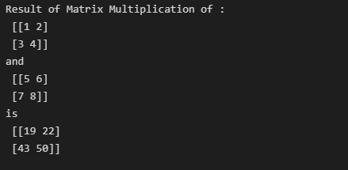

**Inverse Function**

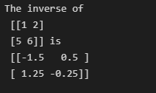

**Finding Rank of the Matrix**

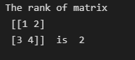

**Determinant of Matrix**

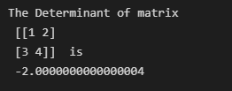

**Statistical Functions with NumPy**

**Maximum & Minimum of Array**

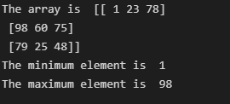

**Finding Mean, SD, Variance and Weighted Avg**

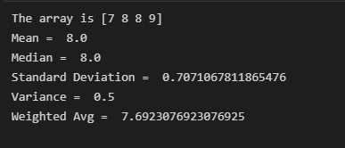

**Generating Data using Probability Distribution**

